ABSTRACT

chronic kidney disease refers to the condition of kidneys caused by conditions, diabetes, glomerulonephritis or high blood pressure. These problems may happen gently for a long period of time, often without any symptoms. It may eventually lead to kidney failure requiring dialysis or a kidney transplant to preserve survival time. So the primary detection and treatment can prevent or delay of these complications. The aim of this work is to reduce the diagnosis time and to improve the diagnosis accuracy through classification algorithms. The proposed work deals with classification of different stages in chronic kidney diseases using machine learning algorithms. The experimental results performed on different algorithms like Naive Bayes, Decision Tree, K-Nearest Neighbour and Support Vector Machine. The experimental result shows that the K-Nearest Neighbour algorithm gives better result than the other classification algorithms and produces 98% accuracy

. Keywords: Chronic Kidney Disease (CKD), Machine Learning (ML), End-Stage Renal Disease (ESRD), Cardiovascular disease, data mining, machine learning,

1.INTRODUCTION

Data mining is a used for the healthcare industry to enable health systems systematically. It uses data for analytics to identify incompetence and best practices that increase the care and reduce costs. Medical treatment is facing a challenge of knowledge discovery from the growing volume of data. Nowadays huge data are collected continuously through health examination and medical treatment. Classification rules are typically useful for medical problems that have been applied mainly in the area of medical diagnosis. Moreover, various machinelearning (ML) techniques have been applied to the field of medical treatments over the past few years. Chronic kidney disease (CKD) is a worldwide common health problem, with predictable lifetime risk of >50%, higher than that for invasive cancer, diabetes and coronary heart diseases. CKD is a long term disorder caused by damage to both kidneys [1], [2]. There is no single cause and the damage is typically permanent and can lead to ill health. In some cases dialysis or transplantation may become essential. Diabetes mellitus is also becoming more common in one cause of CKD. Chronic kidney disease is become more frequently in older people and consequently is likely to increase in the population as a whole. People with chronic kidney diseases are at higher risk of cardiovascular disease and they should be recognized early so that appropriate preemptive measures can be taken [3,4]. CKD is defined as the presence of kidney damagerevealed by the abnormal.

albumin excretion or decreased kidney function. The disease is quantified by measured or estimated by Glomerular Filtration Rate (GFR) that persists for more than 3 month of the CKD patients. Theglomerular filtration rate (GFR) is the best indicator of how well the kidneys are working. The National Kidney Foundation published treatment guidelines for identified five stages of CKD based on diminishing GFR measurements. The guidelines mention different actions based on the stage of kidney disease [5]. A GFR of 90 or above is considered as normal. Even with a normal GFR, it may be at increased risk for developing CKD if the patients have diabetes, blood pressure in high, or a family history of kidney disease. The risk increases with age over 65 are more than twice as likely to develop CKD as people between the ages of 45 and 65. The remaining paper is organized as follows: Section II deals with literature survey about chronic kidney diseases. In section III methodologies used for classifying chronic kidney diseases are discussed. Section IV deals with experimental and its results. Section V gives prediction of chronic kidney diseases with various performances and its.

2.LITERATURE SURVEY

Miguel A. et al. [6] proposed an approach for the management of alarms related to monitoring CKD patients within the eNefro project. The results proof the pragmatism of Data Distribution Services (DDS) for the activation of emergency protocols in terms of alarm ranking and personalization, as well as some observations about security and privacy. Christopher et al. [7] discussed a contextualized method and possibly more interpretable means of communicating risk information on complex patient populations to timeconstrained clinicians. Dataset was collected from American Diabetes Association (ADA) of 22demographic and clinical variables related to heart attack risk for 588 people with type2 diabetes. The method and tool could be encompasses to other risk-assessment scenarios in healthcare distribution, such as measuring risks to patient safety and clinical recommendation compliance. Srinivasa R. Raghavan et al. [8] explored reviews the literature on clinical decision support system, debates some of the difficulties faced by practitioners in managing chronic kidney failure patients, and sets out the decision provision techniques used in developing a dialysis decision support system. Ricardo T. Ribeiro et al. [9] proposed a method, called clinical based classifier (CBC), discriminates healthy from pathologic conditions.

A large multimodal feature database was specifically built for this study. It containing chronic hepatitis, 34 compensated cirrhosis, and 36 decompensated cirrhosis cases, all validated after histopathology examination by liver biopsy. The CBC classification outperformed the nonhierarchical one counter to all schemecomplex to stiffness and free from speckle noise and owns some advantages over the conventional ultrasound imaging in terms of the quality. Chih-Yin Ho et al. [11] presented a computer-aided diagnosis tool based on analyzing ultrasonography images and the system could detect and classify various stages of CKD. The dataset was collected thousands of ultrasonic images from patients with kidney diseases, and the selected typical CKD images were applied to be preanalyzed and trained for assessment. The calculated changeover locations are reference indicators could be responsible for physicians an auxiliary and objective computer-aid diagnosis tool for CKD identification and classification. Al-Hyari et al. [12] proposed a new clinical decision support system for identifying patients with CRF. Some data classification algorithms including Artificial Neural Networks, Decision Tree and Naive Bayes are developed and applied to diagnose patients with CRF and determine the evolution stage of the disease.

The dataset containing 102 instances is collected from patients' records and used for this study. The attained results showed that the developed decision tree algorithm is the most accurate CRF classifier (92.2%) when compared to all other algorithms used in this study. Kuo-Su Chen et al. [13] established a detection system based on computer vision and machine learning techniques for simplifying diagnosis of CKD and different stages of CKD. The proposed system required average time of 0.016 seconds for feature extraction and classification of each testing case. The results presented that the system could produce reliable diagnosis based on noninvasive ultrasonography methods and which could be measured as the most proper clinical diagnosis and medical treatment for CKD patients.

3.DATASET ATTRIBUTES

We have downloaded Chronic Kidney Disease datasets from publically available data

ATTRIBUTES VALUES

1.Age Numerical

2.blood Numerical

3.specific gravity Nominal sg(.005,1.010,1.015,1.020,1.025)

4.Albumin Nominal al-(0,1,2,3,4,5)

5.Sugar Nominal su-(0,1,2,3,4,5)

6.red blood cells Nominal rbc-(normal,abnormal)

7.pus cells Nominal pc-(normal,abnormal)

8.pus cell clumps Nominal pcc- (present,notpresent)

9.Bacteria Nominal ba - (present,notpresent)

10.blood glucose random Numerical

11.blood urea Numerical

12.serum creatinine Numerical

13.Sodium Numerical

14.Potassium Numerical

15.Haemoglobin Numerical

16.Packed cell volume Numerical

17.white blood cell count Numerical

18. red blood cell count Numerical

19.Hypertension Nominal htn - (yes,no)

20.diabetes mellitus Nominal dm - (yes,no)

21.coronary artery disease Nominal cad - (yes,no)

22.Appetite Nominal appet - (good,poor)

23.pedal edema Nominal pe - (yes,no)

24.Anemia Nominal ane - (yes,no)

25.Class Nominal class - (ckd,notckd)

4.CLASSIFICATION ALGORITHMS

A. Naïve Bayes:

The Naive Bayesian classifier is based on Bayes’ theorem with independence assumptions among predictors. A Naive Bayesian model is easy to build, with no complex iterative parameter assessment which makes it especially useful for very large datasets. Even though it’s simple, the Naive Bayesian classifier often does unexpectedly well and is widely used because it often outperforms more refined classification methods. Bayes theorem delivers a way of calculating the posterior probability, P(c|x), from P(c),P(x) and P(x|c). Naive Bayes classifier assumes that the effect of the value of a predictor (x) on a given class (c) is independent of the values of other predictors. This hypothesis is called class conditional independence [16].

(c/x)=p(x/c) p(c)/p(x) (1) P (c|x)

is the posterior probability of given predictor. P(c) is the prior probability of class. P (x|c) is the likelihood which is the ability of predictor given class. P(x) is the prior probability of predictor.

B. Decision Tree: Decision tree builds classification or regression models in the form of a tree like structure. It breakdowns a dataset into smaller and smaller subsets while at the same time an associated decision tree is incrementally established. The last result is a tree with decision nodes and its leaf nodes. Decision nodes have two or more branches. Leaf node represents a classification or decision. The uppermost decision node in a tree which resembles to the finest predictor called root node. Decision trees can switch both categorical and numerical data values. The core algorithm for building decision trees is called ID3 by J. R. Quinlan which employs a top-down and greedy search over the space of possible branches with no backtracking. Algorithm • Start with single node N, with training data D. • If all the data in D belongs to same class, then N becomes leaf. Otherwise attribute ‘A’ is selection method based on splitting criterion. • The instance in ‘D’ is partitioned accordingly . • Apply algorithm recursively to each subset in ‘D’ to each subset in ‘D’ to form decision tree. The algorithm uses Entropy and Information Gain to construct a decision tree [17]. . Entropy ID3 algorithm uses entropy to calculate the similarity of If the sample is completely similar the entropy is zero and if the sample is an equally divided it has entropy of one. E(S)=-Pi log2 pi ------(2)

Information Gain :

The information gain is based on the decrease in entropy after a dataset is split on an attribute. Creating a decision tree is all about finding attribute that returns the highest information gain (i.e., the most homogeneous branches).

GAIN(T,X)=ENTROPY(T)-ENTROPY(T,X) −−− ( 3)

C. K- Nearest Neighbour:

K nearest neighbours is a simple algorithm that stores all available cases and classifies new cases based on a similarity measure (e.g., distance functions). KNN has been used in statistical estimation and pattern recognition already in the beginning of 1970’s as a non-parametric technique. A case is classified by a majority vote of its neighbours, in the case being assigned to the class most common between its K nearest neighbours measured by a distance function. If K = 1, then the case is simply allocated to the class of its nearest neighbour [18].

Algorithm

• Training set: (x1,y1),(x2,y2),,,,,(xn,,yn).

• Assume X:= (x:(1) ,x: (2) ,…,x: (d)) is a dimensional feature vector of real numbers for all i .

• Y: is a class label {1…C}, for all i.

• Find the closest point Xj to Xnew using distance measures.

• Classify by Y knn= majority vote among the K points.

D. Support Vector Machine

A Support Vector Machine (SVM) performs classification by finding the hyper plane that maximizes the margin between the classes. The vectors (cases) that define the hyper plane are the support vectors [19].

Algorithm

• Define an optimal hyper plane: maximize margin. .Extend the above definition for non-linearly separable Problems: have a penalty term for misclassifications .

• Map data to high dimensional space where it is easier to classify with linear decision surfaces: reformulate problem so that data is mapped implicitly to this space. For this type of SVM, training involves the minimization of the error function.

5.METHODOLOGY

components of methodology of chronic kidney disease prediction

.1. Data Collection In this research paper we have used Real world data set for predicting CKD status of a patient. The data collected is widely used data and is available at UCI Machine Learning Repository. This Real data belongs to Apollo Hospital in Tamilnadu, India over a period of 2 months. The data set available is specifically used for Chronic Kidney Disease research. It consists of record of 400 people with their respective 25 CKD related attributes. The data consisted of real numbers, Decimal values and Nominal values.

IMPORTING THE LIBRARIES

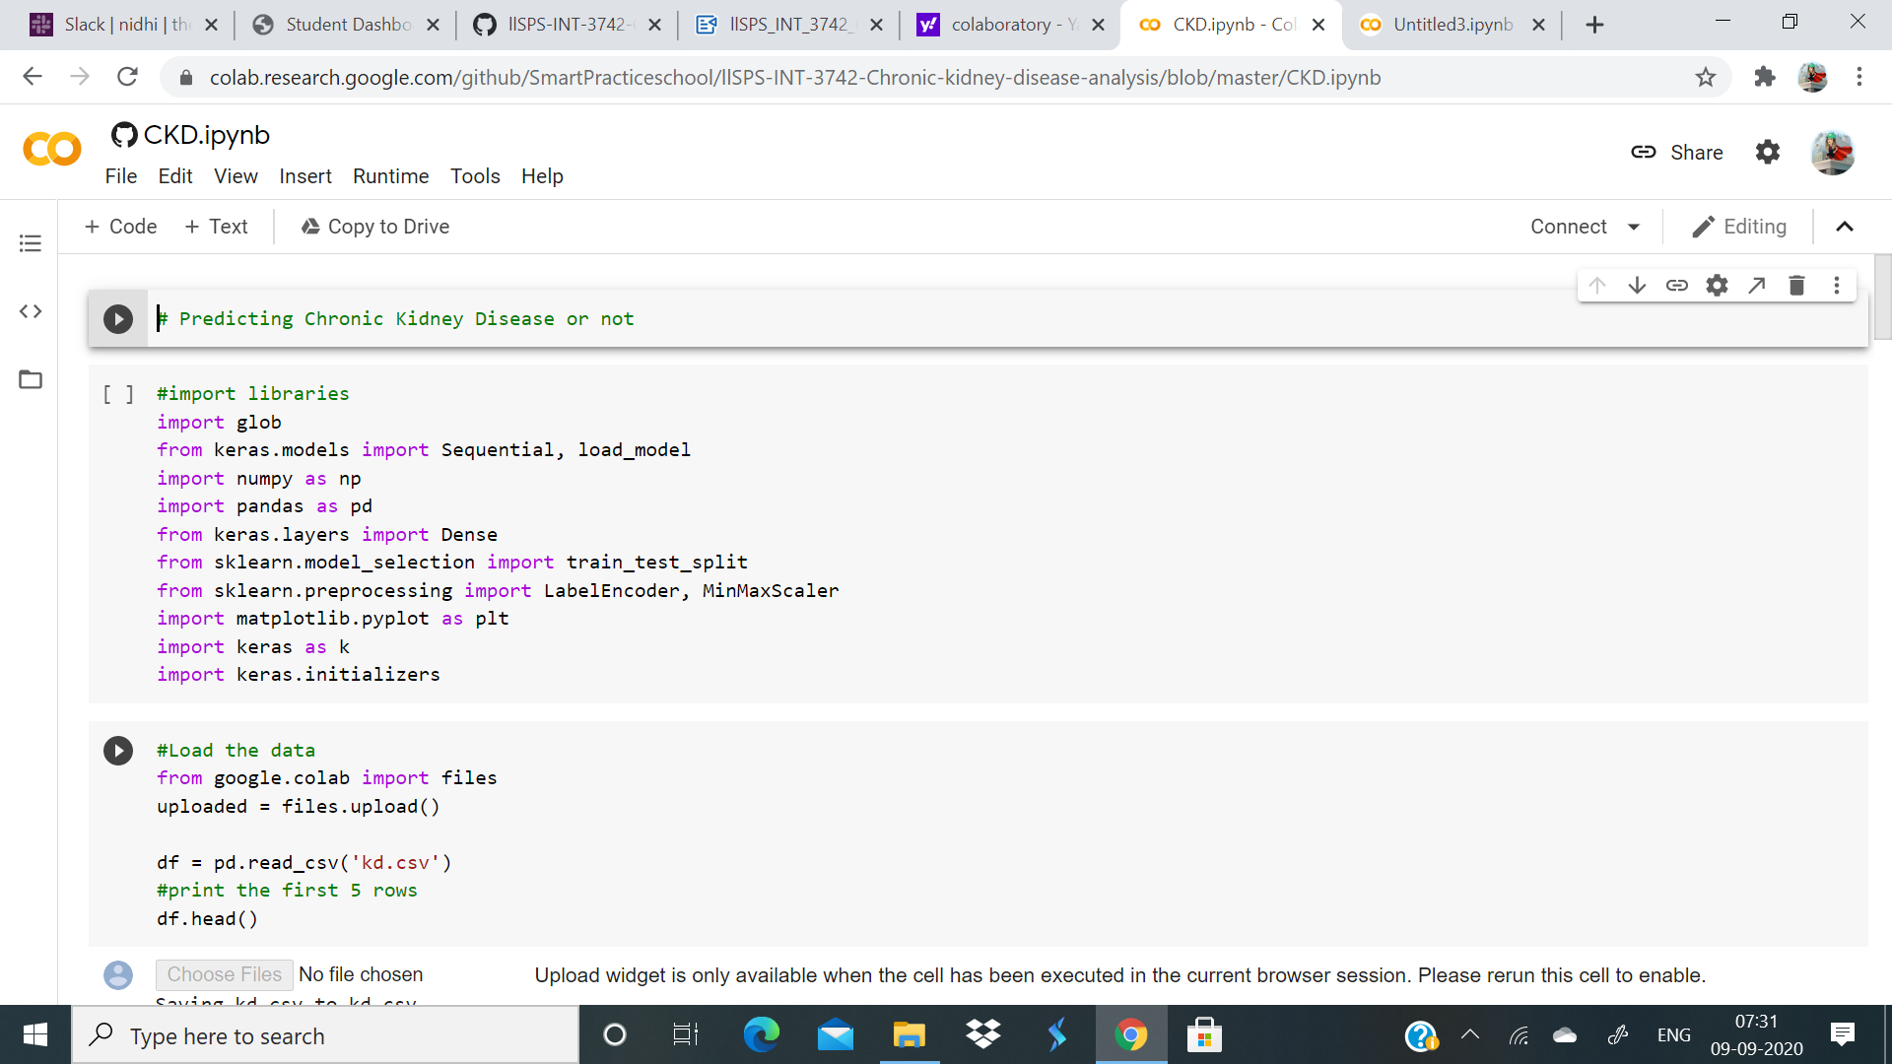

IMPORTING THE DATASET

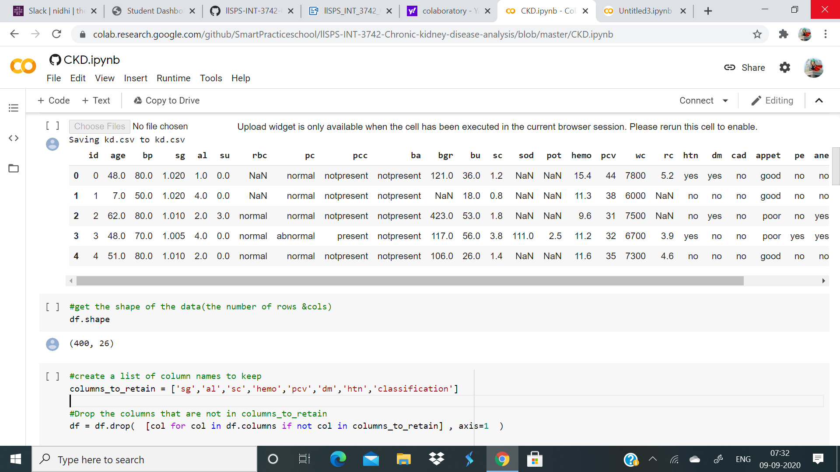

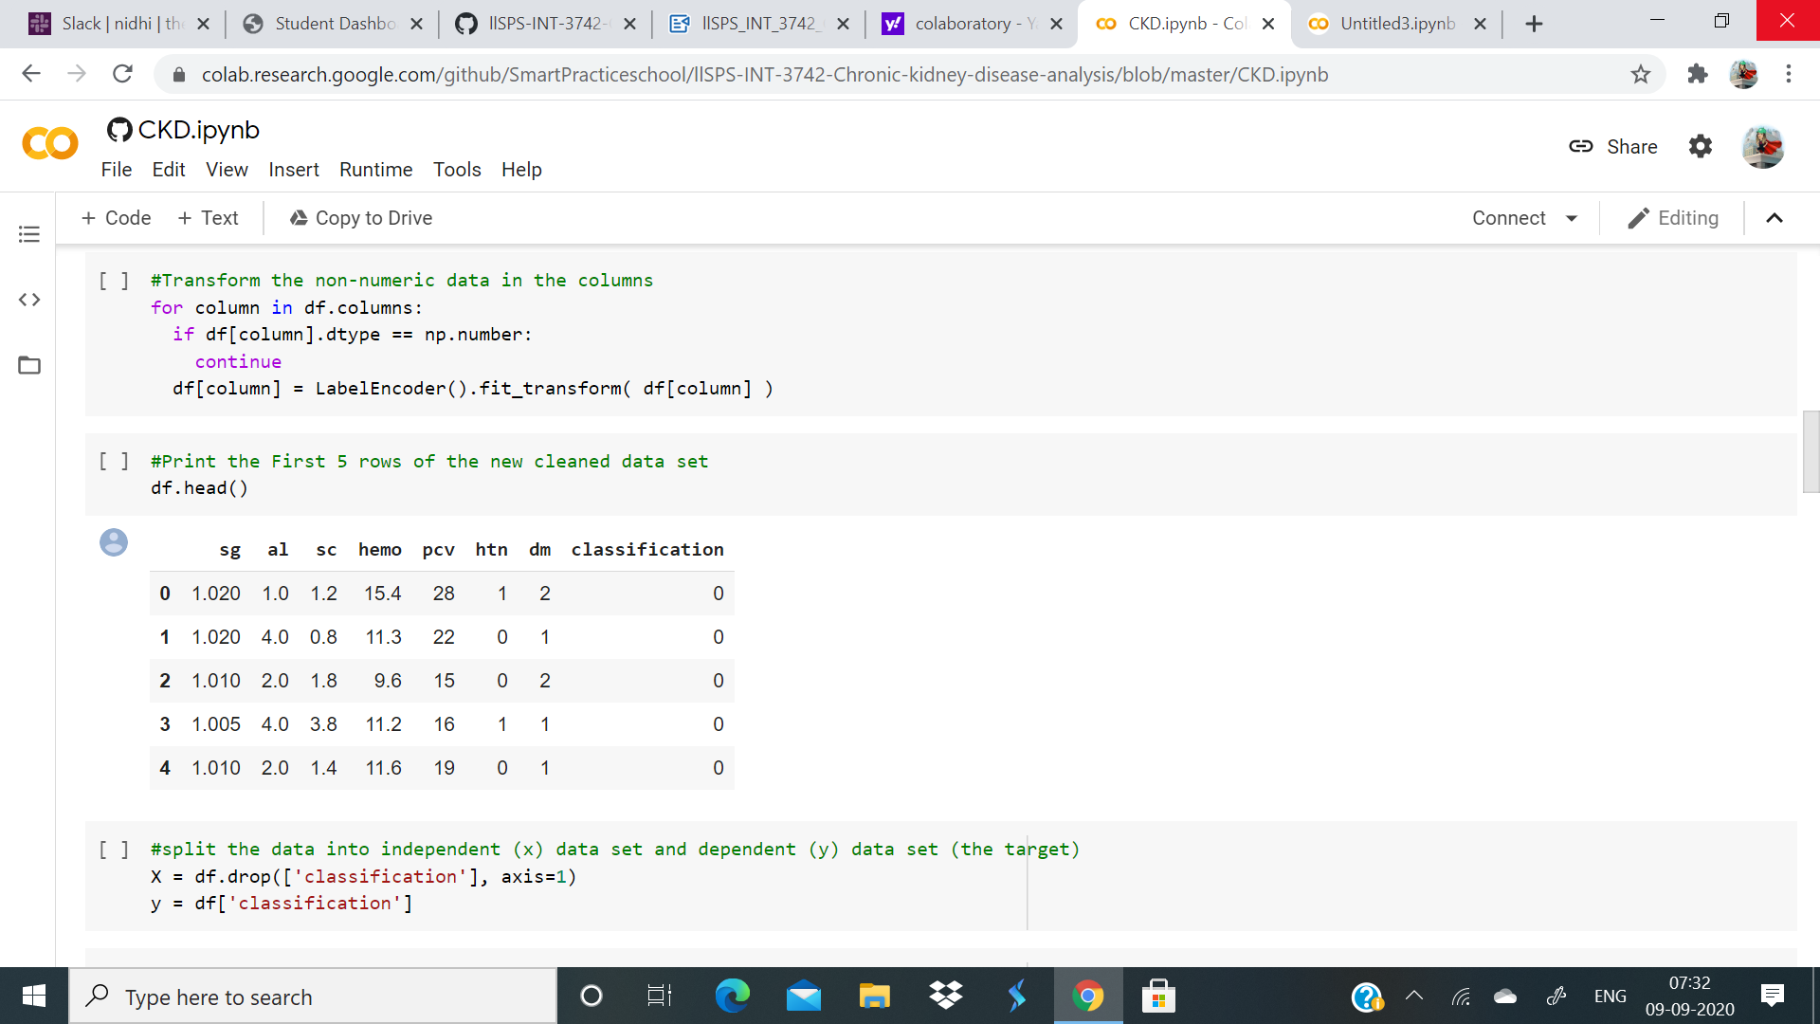

FEATURE SCALING AND

SPLITING INTO TRAIN AND TEST

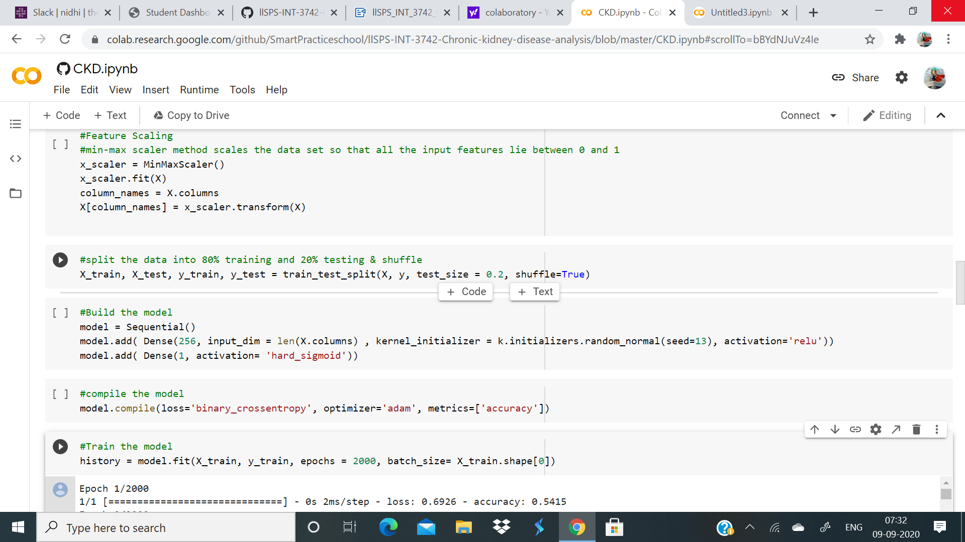

DATA VISUALISATION

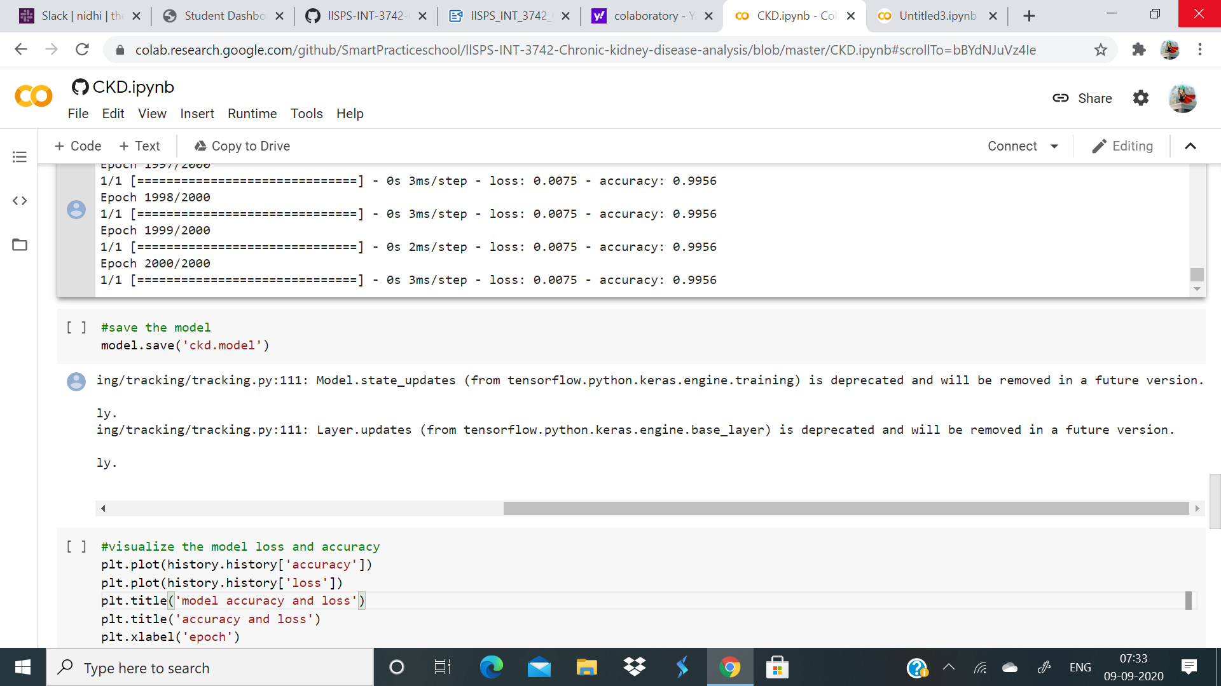

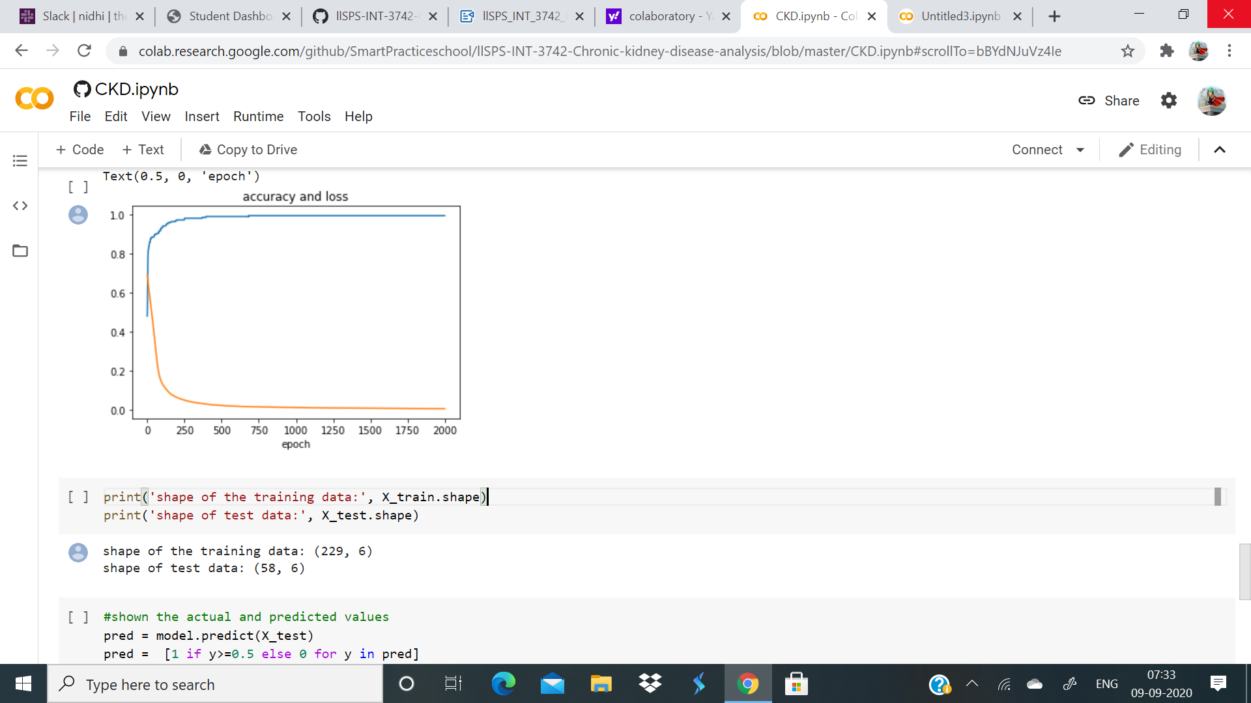

PREDICTION

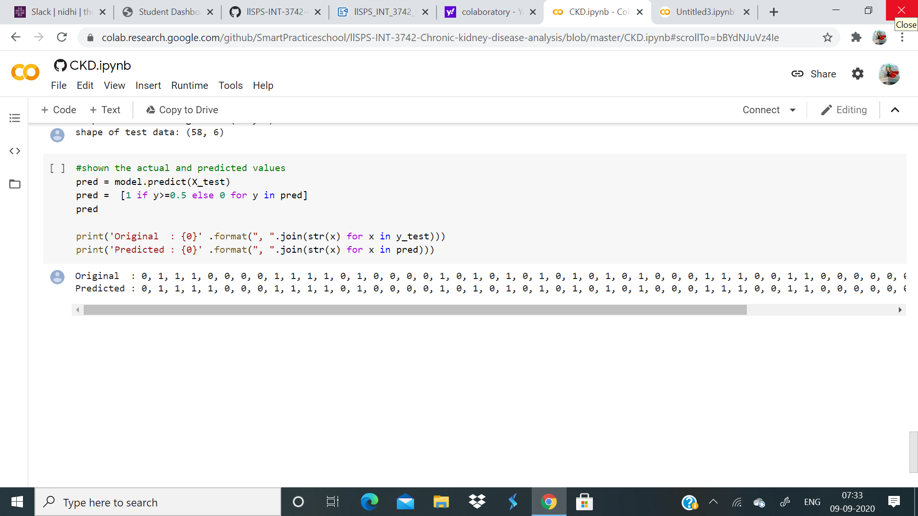

6.FEATURE SELECTION

In this step we select subset of relevant attributes from the total give attributes. This

stage helps in reducing the dimensionality and making the model simpler and easy to

use, thus leading to short training time and high accuracy. To obtain highly dependent

features for CKD prediction we have used Correlation and dependence method. The

term correlation can be defifined as mutual rel relationship between two. In this those

attributes are chosen which highly inflfluence the occurrence of Chronic Kidney Disease .

By using the correlation it is found that 5 attributed were highly correlated to the

occurrence of CKD from the total of 25 attributes.

The 5 attributes selected from a total of 25 attributes are:

1. specifific gravity

2. diabetes mellitus_N

3. albumin

4. packed cell volume

5.red blood cells_N

7.RESULTS

This study is carried to predict weather a patient is suffering from Chronic Kidney

Disease or not. This Prediction model is created in Python programming language. In

our classifification model we have used K-Nearest Neigbour and Naïve Bayes as our

classifification algorithms; both the classifification algorithms were applied to the same

data set collected from UCI Repository. Filtered dataset of 400 people with 5 CKD

related attributes from a total of 25 attributes is used. The Filtered attributed are -

Specifific gravity, diabetes mellitus_N, albumin, packed cell volume and red blood cells_N.

Table2 .

Predictive accuracy of classifification algorithms

Algorithm Accuracy

Naïve Bayes Classififier 96.25%

K-Nearest Neigbour 100%

Table 2 represent the prediction accuracy of both Naïve Bayes and K-Nearest Neigbour vthis research is that it will help Doctors to easily predict CKD with high accuracy and

precision in less time period.

this research is that it will help Doctors to easily predict CKD with high accuracy and

precision in less time period

algorithms. Both the prediction accuracies are compared. Naïve Bayes performed with

an accuracy of 96.25% and KNN performed with an accuracy of 100%. Figure 3 is the

graphical representation of both the prediction algorithms, KNN with 100% accuracy and

Naïve Bayes with an accuracy of 96.25%. In the above fifigure x-axis represents the

accuracy value and the y-axis represents the algorithm used. The above results highlight

that accuracy of KNN algorithm is 3.75% higher than Naïve Bayes classifification

algorithm. The experimental results show that Chronic Kidney Disease can be better

predicted by using K-Nearest Neigbour algorithm with 100% accuracy. The advantage of this research is that it will help Doctors to easily predict CKD with high accuracy and

precision in less time period.

8.ADVANTAGES AND LIMITATIONS

1. Easily identifies trends and patterns

2. No human intervention needed (automation)

3. Continuous Improvement

4. Handling multi-dimensional and multi-variety

data

5. Wide Applications

DISADVANTAGES

1. Data Acquisition

2. Time and Resources

3. Interpretation of Results

4. High error-susceptibility

9.APPLICATIONS

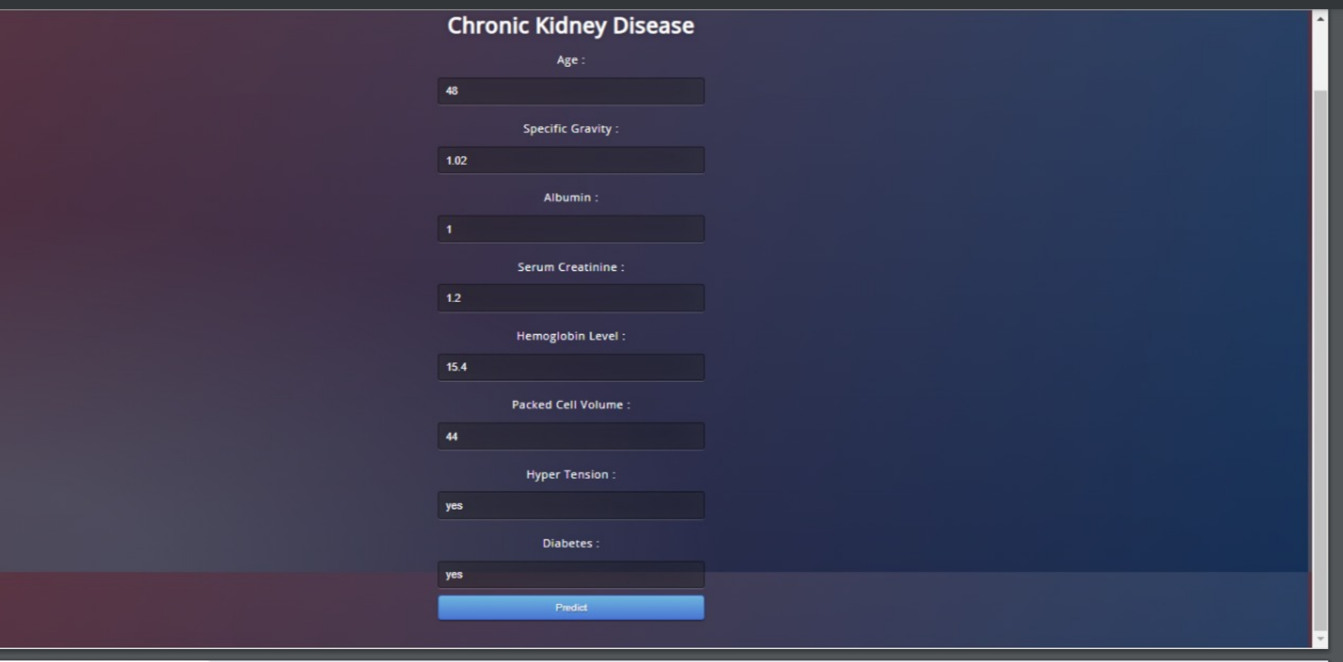

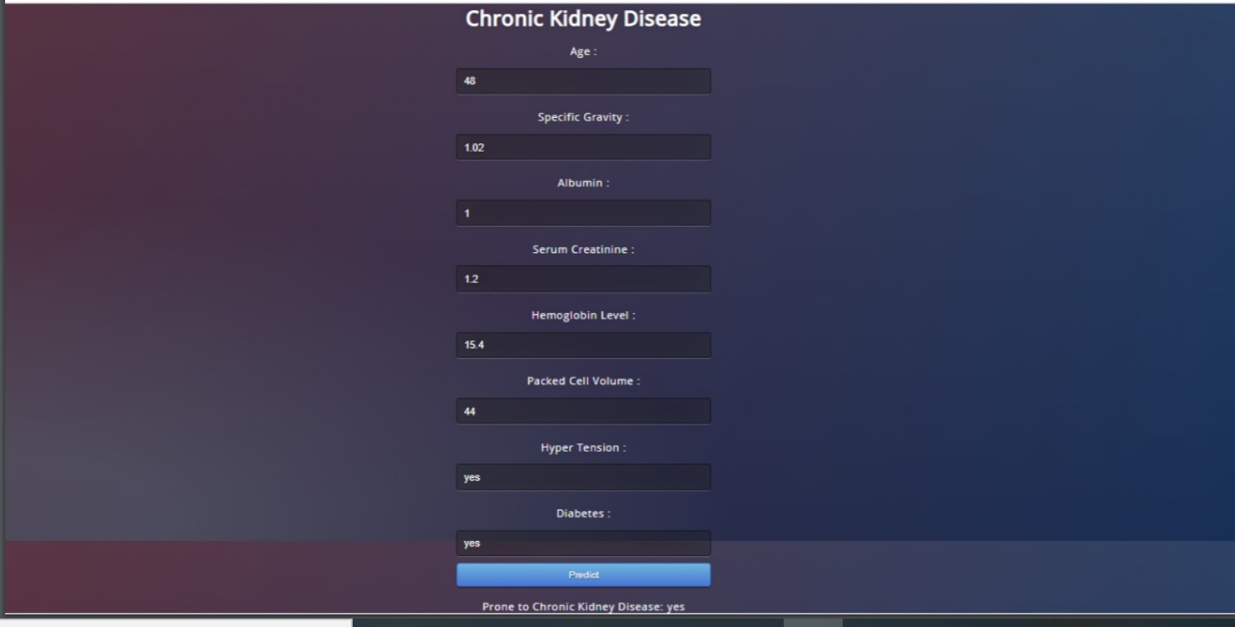

10.FUTURE SCOPE

Early Prediction of Chronic Kidney Disease Using Machine Learning. Predictive analytics

for healthcare using machine learning is a challenged task to help doctors decide the

exact treatments for saving lives. In this paper, we present machine learning techniques

for predicting the chronic kidney disease using clinical data. Four machine learning

methods are explored including K-nearest neighbors (KNN), support vector machine

(SVM), logistic regression (LR), and decision tree classififiers. These predictive models

are constructed from chronic kidney disease dataset and the performance of these

models are compared together in order to select the best classififier for predicting the

chronic kidney disease. Currently, kidney disease is a major problem. Because there are

so many people with this disease. Kidney disease is very dangerous if not immediately

treated on time, and may be fatal. If the doctors have a good tool that can identify

patients who are likely to have kidney disease in advance, they can heal the patients in

time

11.CONCLUSIONS

Accurate prediction of chronic kidney disease is one of the emerging topics in medical

diagnosis. Even though some approaches using real-time features shows very good

performance in terms of accuracy. This work proposes a classifification model to predict

the chronic kidney disease using various machine learning algorithms. All the four

classifification algorithms have been considered for diagnosis of chronic kidney disease.

From the above results, the objective is to fifind the better model for chronic kidney

disease.

The K-Nearest Neighbour is the better model for diagnosis of chronic kidney disease it

attains the accuracy of 98%. It correctly classifified the 980 instances from 1000

instances. Thus fifinally it is observed that KNN is better algorithm for chronic kidney

diagnosis

12.REFRENCES

[1] Sinha, Parul, and Poonam Sinha. "Comparative study of chronic kidney disease

prediction using KNN and SVM." International Journal of Engineering Research and

Technology 4, no. 12 (2015): 608-12

[2] Yildirim, Pinar. "Chronic Kidney Disease Prediction on Imbalanced Data by Multilayer

Perceptron: Chronic Kidney Disease Prediction." In Computer Software and Applications

Conference (COMPSAC), 2017 IEEE 41st Annual, vol. 2, pp. 193-198. IEEE, 2017.

[3] De Lusignan S, Chan T, Stevens P, O’Donoghue D, Hague N and Dzregah B, et al.

“Identifying patients with chronic kidney disease from general practice computer

records” ,Oxford Journals of Family Practice,Vol.3, Issue- 22, 2005, pp.234-241.

[4] Hallan SI, Coresh J, Astor BC, Asberg A, Powe NR and Romundstad S, et al.

“International comparison of the relationship of chronic kidney disease prevalence and

ESRD risk”, Journal American Society of Nephrology,Vol.17, Issue-8, 2006,

[5] Levin A, Coresh J, Rossert J, et al.“Defifinition and classifification of chronic kidney

disease: a position statement from kidney disease”, The New England Journal of

Medicine, 2002, pp.36-42.

[6] Miguel A. Estudillo-Valderrama, Alejandro TalaminosBarroso and Laura M. Roa,“A

Distributed Approach to Alarm Management in Chronic Kidney Disease”, IEEE journal of

biomedical and health informatics,Vol.18, Issue-6, 2014, pp. 1796-1803.

[7] Christopher A. Harle, Daniel B. Neill and Rema Padman, “Information Visualization

for Chronic Disease Risk Assessment”, IEEE Computer Society, 2012, pp.81-85.

[8] Srinivasa R. Raghavan, Vladimir Ladik, and Klemens B. [8] Mitri F.G. et al,

“Vibro-acoustography imaging of kidney stones in vitro Vibro-acoustography”, IEEE

Transactions on Biomedical Engineering 2011.

[9] Chih-Yin Ho, Tun-Wen Pai, Yuan-Chi Peng and ChienHung Lee, “Ultrasonography

Image Analysis for Detection and Classifification of Chronic Kidney Disease”, IEEE

conference published on Intelligent and Software Intensive Systems (CISIS),2012,

pp.624 – 629.

[10] Al-Hyari and Al-Taee, “Clinical decision support system for diagnosis and

management of Chronic Renal Failure”, IEEE Jordan Conference on Applied Electrical

Engineering and Computing Technologies (AEECT), 2013, pp.1-6.

[11] Kuo-Su Chen, Yung-Chih Chen and Yang-Ting Chen, “Stage diagnosis for Chronic

Kidney Disease based on ultrasonography”, IEEE International Conference on Fuzzy

Systems and Knowledge Discovery (FSKD), 2014, pp. 525 – 530.

[12] Anne Rogers, Anne Kennedy, Thomas Blakeman and Christian Blickem,

“Non-disclosure of chronic kidney disease in primary care and the limits of instrumental

rationality in chronic illness self-management”, ELSEVIER Social Science & Medicine

[13] Mohammed Shamim Rahman, Rajan Sharma and Stephen J.D. 14 ABSTRACT

Brecker,“Transcatheter aortic valve implantation in patients with pre-existing chronic

s with pre-existing chronic kidney disease”, ELSEVIER International Journal of Cardiology Heart & Vasculature ,

Vol.5, 2015, pp. 9–18.

[14] https://en.wikipedia.org/wiki/Data_mining

THANK YOU ,SMART BRIDGE